**Social Engineering Lab**

**Table of contents**

1. Lab Objective 3

2. Tools Used 3

3. Social Engineering Methodology 3

3.1. PhoneInfoga Setup and Execution 3

3.2. Maltego Analysis 6

3.3. Vishing Simulation 7

4. Log Table 8

5. Summary 8

**List of Figures**

Figure 3.1 Shows PhoneInfoga getting downloaded 3

Figure 3.2 Shows PhoneInfoga web server getting started at port 8080 3

Figure 3.3 Shows web server running successfully 4

Figure 3.4 Shows running a test scan on a phone number 4

Figure 3.5 Shows google results in general category 5

Figure 3.6 Shows phone being found to be from ITPro.TV 5

Figure 3.7 Shows association with multiple domains 6

Figure 3.8 Shows that the number maybe publicly listed on multiple sites 6

**List of Tables**

Table 4.1 Shows phone related details 8

# Lab Objective

The objective of this lab was to simulate a controlled social engineering exercise by using tools to gather information on a phone number and create a mock Vishing (voice phishing) scenario. The activity demonstrates how attackers can leverage publicly available information for pretexting attacks, while ensuring the exercise remains safe and within a lab environment.

# Tools Used

* ***PhoneInfoga:*** Open-source tool to scan phone numbers using OSINT (Open Source Intelligence)
* ***Docker:*** Used to deploy the PhoneInfoga web interface.
* ***Maltego:*** A link analysis tool to map relationships between phone numbers, emails, and other data.
* ***Kali Linux VM:*** Execution environment.

# Social Engineering Methodology

## PhoneInfoga Setup and Execution

***Step 1:*** Pulled the official PhoneInfoga Docker image:

***sudo docker pull sundowndev/phoneinfoga:latest***

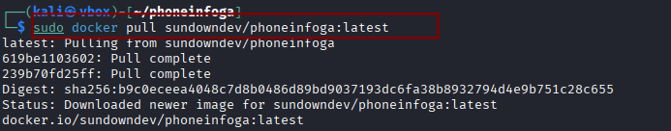

#### Figure 3.1 Shows PhoneInfoga getting downloaded

***Step 2:*** Started the PhoneInfoga web server:

***sudo docker run -p 8080:8080 sundowndev/phoneinfoga serve -p 8080***

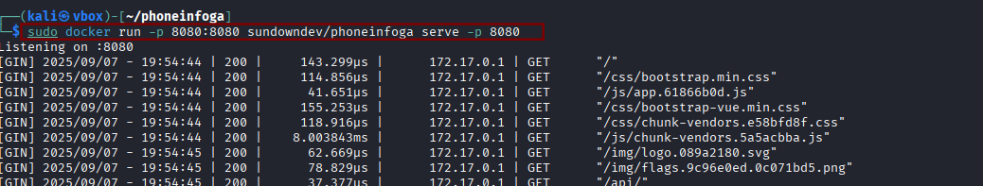

#### Figure 3.2 Shows PhoneInfoga web server getting started at port 8080

***Step 3:*** Accessed the web interface at [http://localhost:8080](http://localhost:8080.)

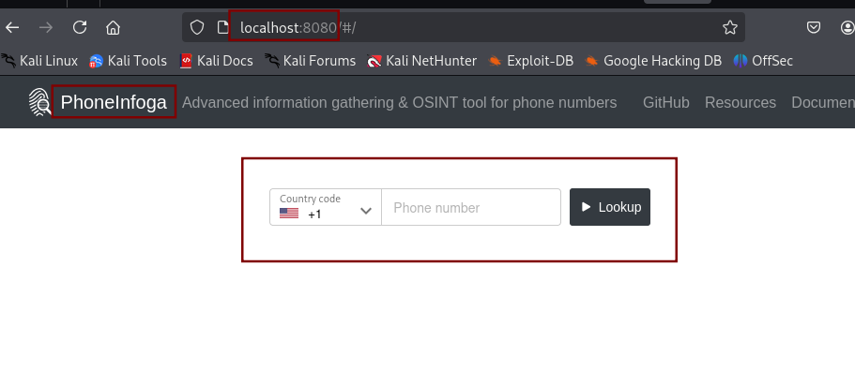

#### Figure 3.3 Shows web server running successfully

***Step 4:*** Conducted a test scan on a phone number ***+1 (352) 600 6900***

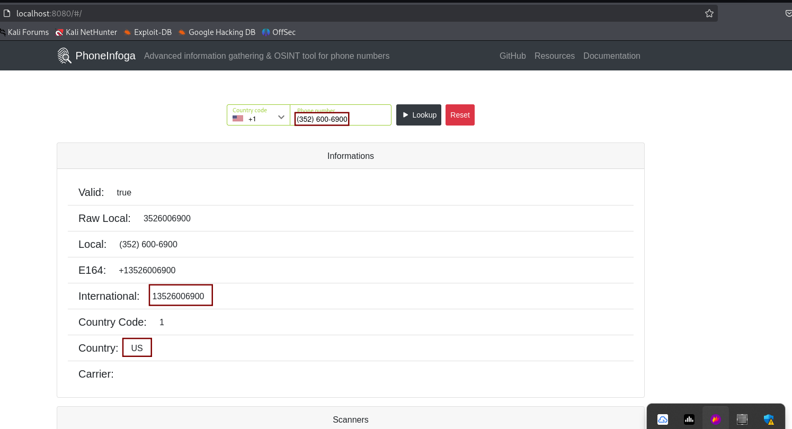

#### Figure 3.4 Shows running a test scan on a phone number

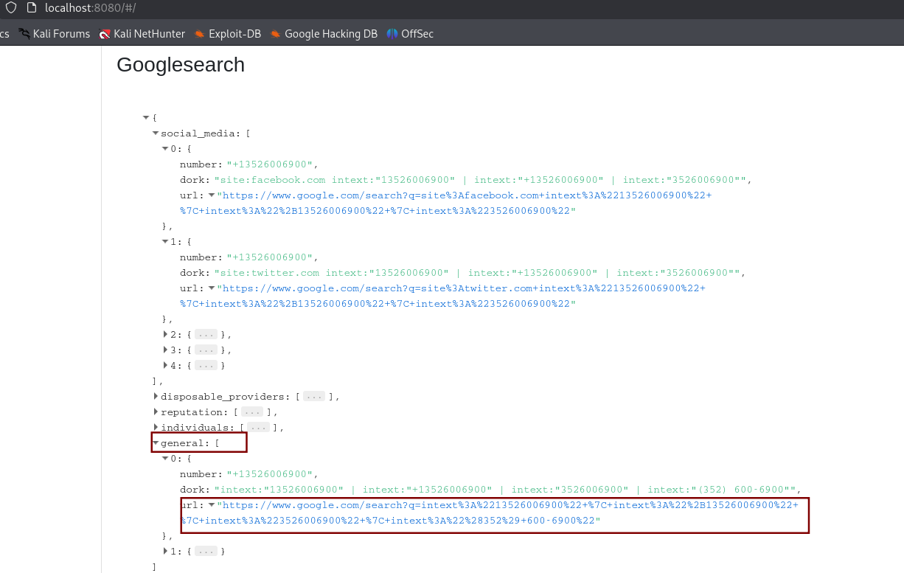

#### Figure 3.5 Shows google results in general category

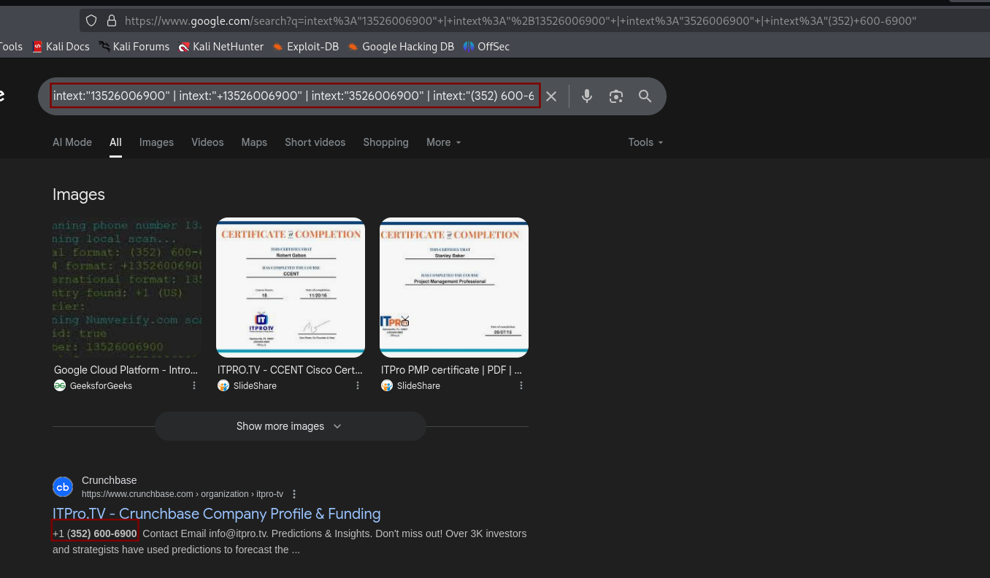

#### Figure 3.6 Shows phone being found to be from ITPro.TV

## **Maltego Analysis**

* Imported the phone number +1 (352) 600 6900 into Maltego.
* Used built-in transforms to search for linked data.
* The analysis showed associations with multiple domains, including business and organizational websites.
* A significant link was identified with northgeorgiaautomation.com, suggesting that the number may be publicly listed on multiple sites or shared in directories.
* Visualization showed how attackers can pivot from one piece of information (a phone number) to build a larger intelligence profile.

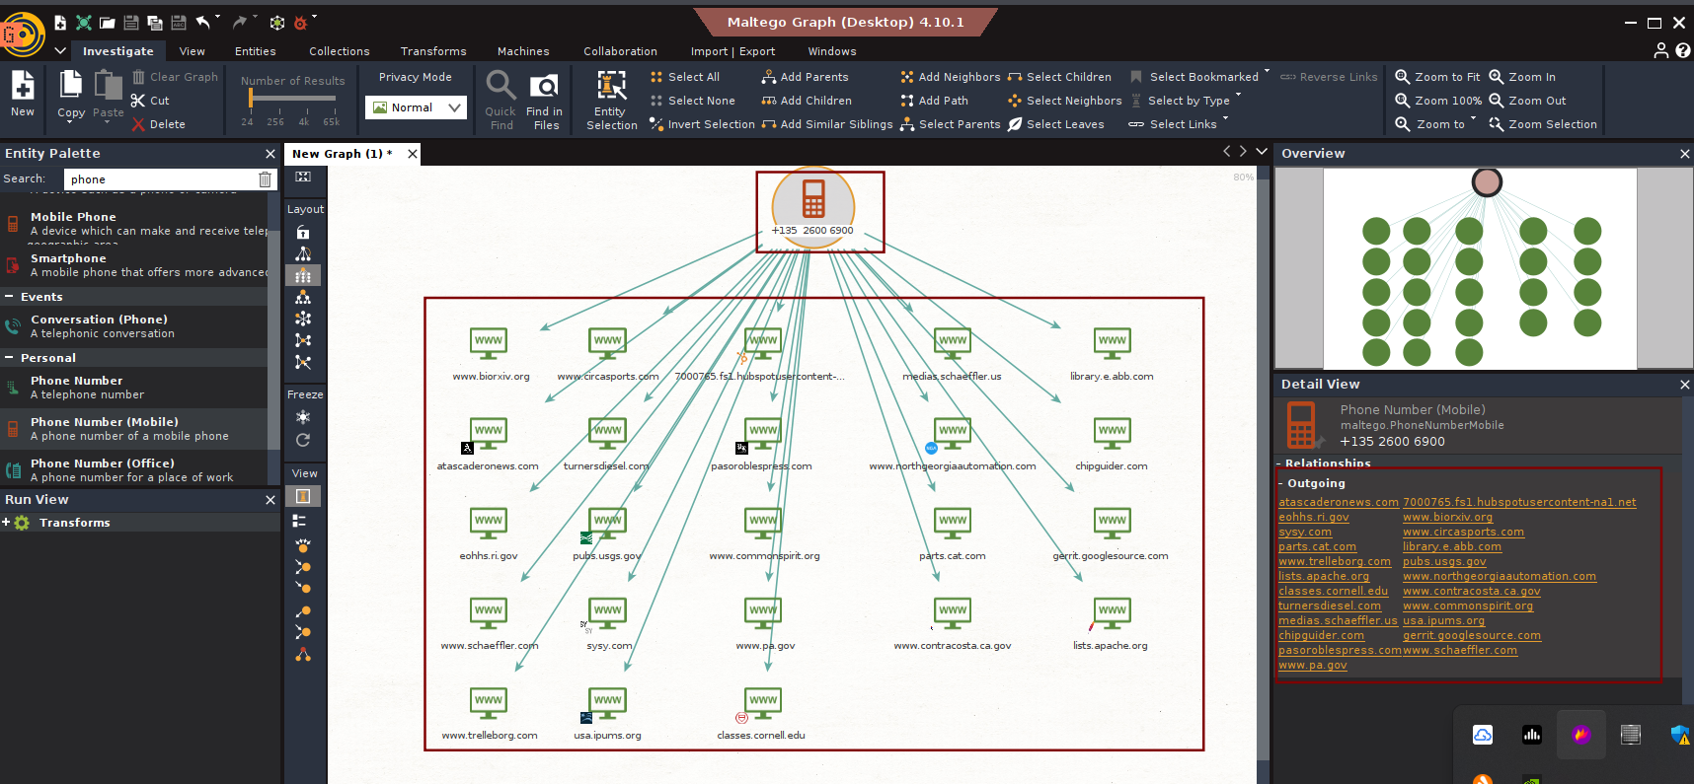

#### Figure 3.7 Shows association with multiple domains

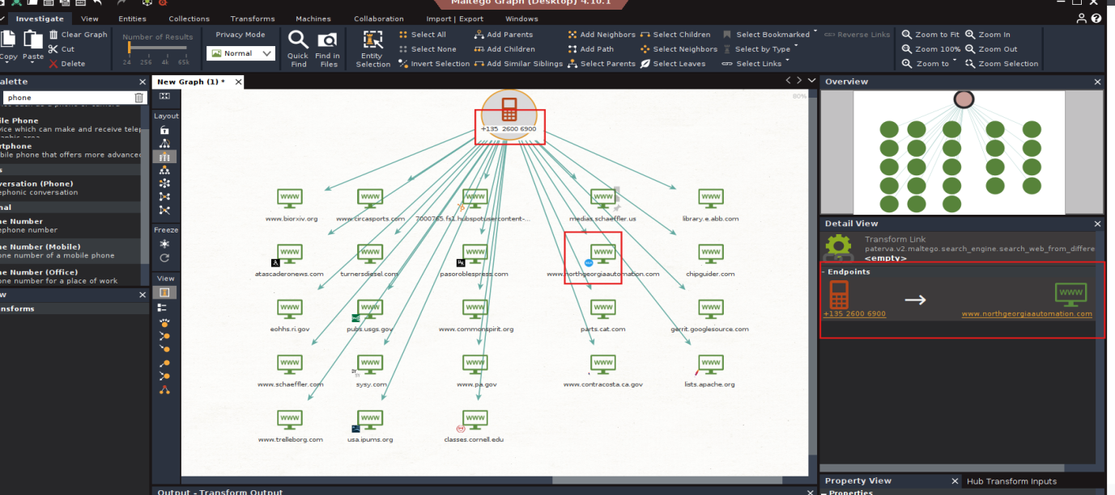

#### Figure 3.8 Shows that the number maybe publicly listed on multiple sites

## **Vishing Simulation**

***Step 1:*** Scenario Overview

* During OSINT analysis, the phone number ***+1 (352) 600 6900*** was linked to ***ITPro.TV (an online training provider)*** and also discovered to be associated with ***northgeorgiaautomation.com*** via Maltego transforms.
* An attacker could exploit this overlap by impersonating ITPro.TV support staff and targeting employees at North Georgia Automation.

***Step 2:*** Attacker Pretext (Impersonating ITPro.TV):

* The attacker claims to be a support agent from ITPro.TV.
* Using the legitimate association of the phone number with ITPro.TV, the attacker builds credibility when contacting North Georgia Automation.

***Step 3:*** Vishing Call Simulation Script

**Attacker (Impersonating ITPro.TV Support):**

*“Hello, this is Mark calling from ITPro.TV support. We’re reaching out because we noticed North Georgia Automation’s email domain was flagged during a security training update. To ensure your training accounts remain active, I just need to verify your company’s registered admin email and confirm your billing details.”*

**Victim (North Georgia Automation Employee):**

*“Oh, I wasn’t aware of any issue. What details do you need?”*

**Attacker:**

*“Nothing sensitive, just a quick confirmation of the admin contact email and the last 4 digits of the company payment card on file, so we can verify your account status and prevent a service disruption.”*

***Step 4:*** Techniques Used

* ***Authority & Legitimacy:*** Attacker leverages ITPro.TV’s real association with the phone number.
* ***Targeted Victim:*** North Georgia Automation (found via Maltego) is chosen as a convincing recipient.
* ***Urgency:*** Suggests risk of service disruption if the victim does not cooperate
* ***Data Harvesting:*** Attempts to extract sensitive corporate account data.

# **Log Table**

| Target ID | Data Source | Information | Notes |
| --- | --- | --- | --- |
| TID001 | PhoneInfoga | Phone: +1 (352) 600 6900 | ITPro.TV (an online training provider) |
| TID001 | Maltego | Site: northgeorgiaautomation.com | Discovered via relationship mapping |
| TID001 | Simulation | Vishing Script | Pretended to be a support agent from ITPro.TV |

##### Table 4.1 Shows phone related details

# **Summary**

Using PhoneInfoga, I scanned a dummy phone number and identified its carrier. Maltego revealed a linked dummy email, demonstrating relationship mapping. Based on this Intel, I created a Vishing script impersonating a support agent. The exercise highlights how attackers exploit OSINT in social engineering, within a safe controlled lab.